Zac Lee
30038472
Web Design & Development
Assessment 2 of 2

Contents
Introduction 3
Layout 3
Navigation 3
Dynamic Scaling 3
Accessibility 4
Load Times 4
Outstanding Issues 4
Change Log 5
Whole Site 5
Side Navigation – Desktop & Tablet 5
Top Navigation 5
Home Page 5
About Page 5
Skills Page 5
Showcase Page 5
Contact Page 5
Footer 5
Desktop Mode 6
Tablet Mode 6
Mobile Mode 6
Testing 6
References 10
Appendix 11
A. Skills box scrolling images 11
B. Skills - 2 columns for tablet & 1 column for phone 11
C. Side nav showing previous and next sections 11
D. Smooth Scrolling 11
E. Showcase carousel buttons are above the images 11
F. Show logo on Mobile Display 11
G. Showcase not showing correctly on mobile 11
H. Background gradient on hamburger menu 11
I. Mobile 4G site loading test 11
J. New windows for images 11
K. Windows opening in the centre of the screen 11
L. New windows disabled in tablet and mobile 12
M. Images in Skills and Showcase still visible 12
N. Images should be tablet 2 per row / mobile 1 per row 12
O. Mobile 4g with lazy load and prefetch 12
P. Submit Form 12
Q. Side navigation updating dynamically 13
R. Smooth Scrolling Retest 13
S. Carousel buttons above the images 13
T. Logo displays correctly on mobile 13
U. Background gradient on nav showing on all sections 13

Introduction
This evaluation of the Choose Design Website will investigate how dynamic the website is on various devices such as desktop, tablet and mobile phones, and the techniques and design principles used to create the website and how well on conforms to industry standards for layout and accessibility.

Layout

Navigation
The navigation for the website is extensive, and lets users know exactly where they are and what the previous and next pages are the logo on the top left is also a link to the home page and the desktop navigation bar at the top of the page on the right-hand side with a logo on the left-hand side, this is where users would expect to find it, and the first place they would look when trying to navigate around the site, this follows the real-world consistency standards as advised by Neilsen (2024).
The tablet navigation uses a simplified navigation system at the right-hand side showing the previous and next section and a home button in the middle, this is ideal for a single page site with only a small number of sections. The navigation is exactly where your hand rests and is easy to reach with your thumb without stretching or moving your hand. This improves user experience and accessibility according to Aleksei (2024).
According to Omarov (2023) the hamburger menu is in a familiar location on the mobile top right-hand side, this is industry standard and is easily found by users but is not easy for thumb friendly navigation and should be moved to the bottom centre.

Dynamic Scaling
Another strength of the website is the dynamic layout works for a range of screen sizes that scales well up to 4k down to 1080p for desktops, with various specific media queries for 2k desktops screens, tablet mode 1280x800px landscape, and low-resolution mobiles 440x954px with a vertical layout. To improve on this, more media queries could be added for high resolution phones and tablets, with a landscape and vertical mode.
The background images for the site are 4k for desktop which scales down to 1080px depending on resolution, and the image changes to 1280p version for tablet and a 440p vertical image for mobile so each device will have the best quality without extended load times.
On desktop there are links that open new windows to view large images at 1440x900px so it can be viewed on a desktop monitor as low as 1080p these links will deactivate on low resolution tablets and mobile screens with a resolution width less than 1300px.
On the skills section the layout shifts depending on screen resolution starting at three columns for desktops two columns for tablets, and one column for mobile devices.

Accessibility
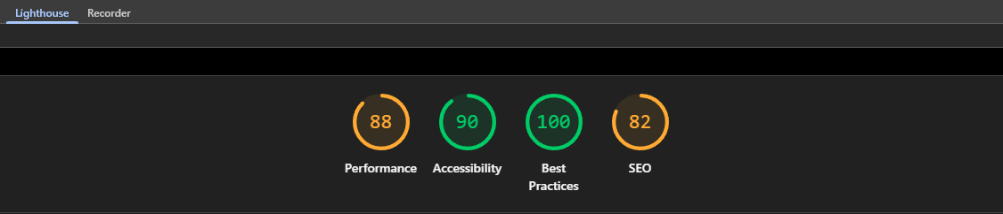
Figure 1: Google Lighthouse Desktop Site Test
This website aims to be accessible to most people whilst maintaining the design choices - scoring 90% on the Google Lighthouse Site Test in Chrome Dev Tools – See Figure 1, only a minor issue on the contacts page where the WhatsApp, LinkedIn and Email icons do not have a full name to what they link too. Contrast between text at 1rem text with a 0.8 transparent background is fine over the background images conforming to WCAG - AA standards according to Cann (2024).
An issue that has been noted is multiple items using the same ID, this needs to be changed to a class as it could affect some accessibility tools such as screen readers.

Load Times
Load times are good – around 500ms for desktop which is well below the specified three second rule where users start to get frustrated and leave according to Das (2025) – images have been tailored to the fit the device they are for using preload on the home page, prefetch on the other background images and lazy load on anything not immediately visible to improve load times. Smaller images have also been used for low resolution devices.
Further improvements have been made using the .webp format, and could be improved again using image cache according to the Lighthouse test review.

Outstanding Issues
Smooth scrolling is dependent on Windows animation features being turned on; they are on by default but users on a slow computer may turn them off – this will result on the website jumping from one section to another when using the navigation bar.
Third party JavaScript from web3forms for the contact form has an error highlighted in the browser, the JavaScript works but anything placed underneath this section on in index.js will not work, anything else must be placed above this, fixing the highlighted issue breaks the functionality, a potential fix for this would be to have it in a separate JS file.
Whilst on localhost there is no phone application to link to when clicking the phone number or phone icon to make a call. This has temporarily been changed to the WhatsApp.

Change Log
Overall, the website closely matches the original Figma design, style and theme throughout the whole site, with a few noticeable changes to the skills and showcase sections, skills section has been changed to a single scrollable box instead of 3 boxes and the Showcase section a single carousel is used instead of buttons that open to a larger image, there is also a footer added. See below for all changes.

Whole Site
Opacity – all opacity changed to 0.8 – better consistency
Whole site – images have been set to lazy load when not in a visible are – skills / showcase – faster loading times when opening the website
Whole Site – Titles added to Skills and Showcase – looks better

Side Navigation – Desktop & Tablet
Middle button - logo – rotated 15 degrees – Looks better
Top and bottom buttons – text is displayed vertically instead of horizontally 90 degrees – Looks better
Top and bottom buttons – no arrows – Looks better

Top Navigation
Top nav – Links renamed – Home, About, Skills, Showcase and Contact – Cleaner Look

Home Page
Home – Added 3 text boxes – Design, Develop and Deploy – leading to slogan – better flow leading to the slogan

About Page
About – text change to gold boxes with blue text, going around image – Looks better
About – image has been changed to a robot version of me – to better fit with the theme
About – image was changed to as side view that goes front facing on mouse over

Skills Page
Skills – changed to a scrolling box with certificates – looks better / quicker

Showcase Page
Showcase – is now a full screen carousel – bigger images / quicker

Contact Page
Contact form – changed number of fields to fit the web3forms default – for working submission feature
Contact form –changed name field on web3forms to subject

Footer
Footer added
Footer – link added – home section
Footer – View Figma Design – New window – 1440x900px – Password1
Footer – View Evaluation.pdf - New window
Footer – downloadable Evaluation.docx

Desktop Mode
Desktop – Skills are clickable, opening new large view window
Desktop – Showcase – carousel images are clickable opening a new large view window
Desktop – new windows now appear in the centre of the screen

Tablet Mode
Tablet mode – side navigation only – easy to reach, natural position for hand / thumb

Mobile Mode
Mobile – Home – extended left side of the text boxes to the edge of the page
Mobile – Banner – rotated 90degrees under image – for a vertical layout
Mobile / Tablet – Skills and showcase links have been disabled and can only be viewed in the original window – due screen site
Mobile – background have been set to preload the home page and prefetch the other 4 sections for - faster loading times

Testing
TEST | TYPE | TEST DATA | EXPECTED OUTCOME | ACTUAL OUTCOME | SUCCESS / FALL | NEXT STEPS | EVIDENCE
1 | N | On the skills section certificate images are scrollable | Certificates scroll in within confines of the box | Certificate images scroll correctly | S | none | A1, A2
2 | N | There should be 3 columns on desktop, 2 columns on tablets and 1 column on mobile | 3 columns on desktop, 2 columns on tablets and 1 column on mobile | There are 3 columns on desktop, 2 columns on tablets and 1 column on mobile | S | none | B
3 | N | Side navigation bar should show previous and next sections depending on the section you are on | Side navigation bar updates dynamically show links to the previous and next section | Top button showing contacts section, nothing on the bottom button | F | Debug and fix (was working) - Remove JS affecting this - Fixed | C
4 | N | Smooth Scrolling when clicking a link – doesn’t jump sharply to the next section further down the page | Smooth Scrolling when clicking a link – doesn’t jump sharply to the next section further down the page | Clicking a link makes the page jump to the next section | F | Debug and fix | D
5 | N | Showcase carousel buttons should be above the images | Carousel Next and Previous buttons should be above the images | Next and previous buttons are behind the images | F | Update CSS | E
6 | N | Logo on mobile | Show logo on mobile | Turns the logo into a button on the drop-down menu | F | Redesign logo for mobile | F
7 | N | Images display correctly on showcase carousel | Images are the correct size for all screens | Images overflow on mobile carousel | F | Add width 100% to stop overflow - Fixed | G
8 | N | Gradient Background showing behind menu | Gradient background shows on all sections | Only showing on home section | F | Add position: Fixed | H
9 | N | Mobile – 4g site load test | Site should load quickly | Background sections load in quickly – certificates / showcase images are slow - 28s | F | Lower image resolution / file size for quicker load times - Fixed | I
10 | N | Skills and showcase images open in a new window | Images open in a new window depending on width and height | Images do open in a new window that on top of the current page | P | None | J
11 | N | New windows should open in the centre of the screen | Images to open in a new window in the centre of the screen | New windows appear in the top left of the screen | F | Add JS to fix | K
12 | N | New windows disabled in tablet and mobile | Links to new window should not be clickable in tablet and mobile mode | New windows appearing | F | Add JS to fix - Fixed | L
13 | N | Disabled links in the skills and showcase section should still be visible – showing images | Skills certificates should be scrollable, and the buttons should work on the carousel | Certificates are scrollable, carousel buttons are disabled | F | Update above JS to skip ‘.next’ and ‘.prev’ button classes on carousel - Fixed | M
14 | N | Skills should be cert images should be 2 on tablet and 1 on mobile with new links to windows disabled | 2 certificates per row on tablet and 1 per row on mobile | 3 per row showing on mobile after wrapping images in <a> tags | F | Update CSS - Fixed | N
15 | N | Mobile 4g – with Lazy load and prefetch | Mobile background section load first and Images with lazy load only load when visible | Images only load when visible – load times faster | P | Load times dropped from 28s to under 5s, with extra image loading when image is in view – home page 1.35s to load, desktop 580ms Wi-Fi / LAN | O
16 | N | Form Submit works | Form details submit and details are sent to my email | Form sends correctly – JS highlighted as incorrect | P | Form sends correctly and fixing the JS breaks the form – ignore error and keep at the bottom to stop it affecting anything below | P1, P2
17 | N | Re-test of test 3 | Side navigation bar updates dynamically show links to the previous and next section | Top button showing contacts section, nothing on the bottom button | P | Fully working – updated index.js | Q
18 | N | Retest of test 4 | Smooth Scrolling when clicking a link – doesn’t jump sharply to the next section further down the page | Clicking links smoothly scrolls down the page to the next section | P | Fully Working - animation effects were disabled in advance setting in windows on a slow computer – this disables smooth scrolling on browsers | R
19 | N | Retest of test 5 | Carousel Next and Previous buttons should be above the images | Next and previous buttons are now above the showcase images | P | Fully working | S
20 | N | Retest of test 6 | Logo displays on the correctly on mobile | Logo displays correctly and is fully hidden by the drop-down menu when its open | P | Fully working | T
21 | N | Retest of test 8 | Gradient background shows on all sections | Gradient for navigation is fixed to the top of the screen | P | Fully working | U
22 | N | Retest of test 11 | New windows open in the centre of the screen not the top left | Links to new windows open in the centre of the screen | P | Fully working | V

References
J. Nielsen (2024) 10 Usability Heuristics for User Interface Design. Available at: https://www.nngroup.com/articles/ten-usability-heuristics/ (Accessed: 10th December 2025).
Akeksei (2024) The Art of Thumb-Friendly Navigation: Mobile Design Essentials. Available at: https://medium.com/@Alekseidesign/the-art-of-thumb-friendly-navigation-mobile-design-essentials-095202d5f8a9 (Accessed: 10th December 2025).
M. Cann (2024) A plain language guide to WCAG contrast requirements. Available at: https://medium.com/design-bootcamp/a-plain-language-guide-to-wcag-contrast-requirements-6fe18569d5df (Accessed: 11th December 2025).
Das, S. (2025) How fast should a website load in 2025? Available at: https://www.browserstack.com/guide/how-fast-should-a-website-load (Accessed: 11 December 2025).
Ulvin Omarov (2023) Hamburger Menu Position: Left or Right Top Corner? Available at: https://medium.com/design-bootcamp/hamburger-menu-position-left-or-right-top-corner-7a57aedbe95c (Accessed: 11 December 2025).

Appendix

Skills box scrolling images

A1.

A2
.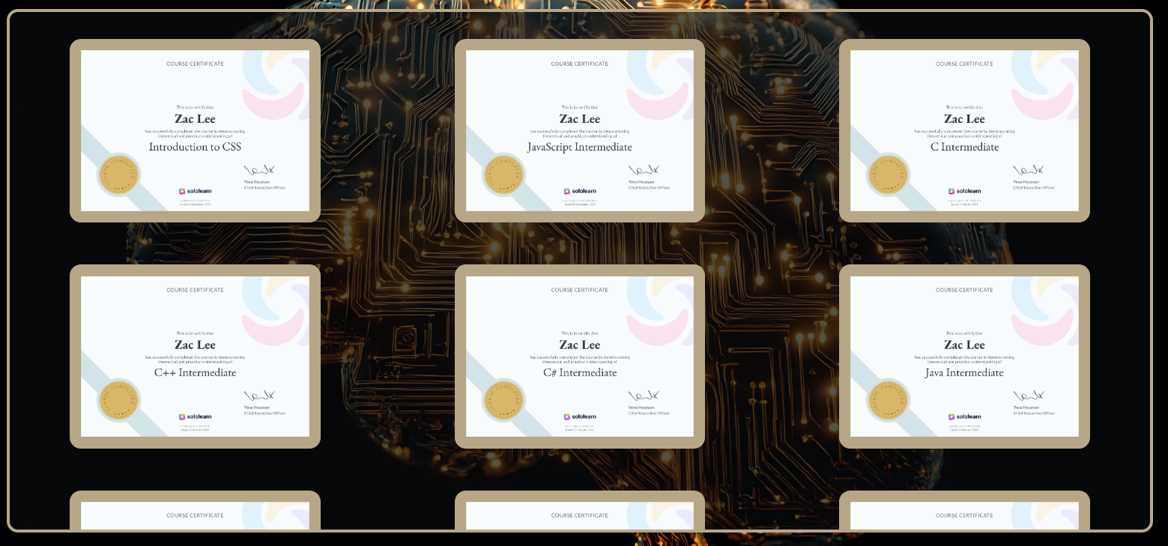

B. Skills - 2 columns for tablet & 1 column for phone
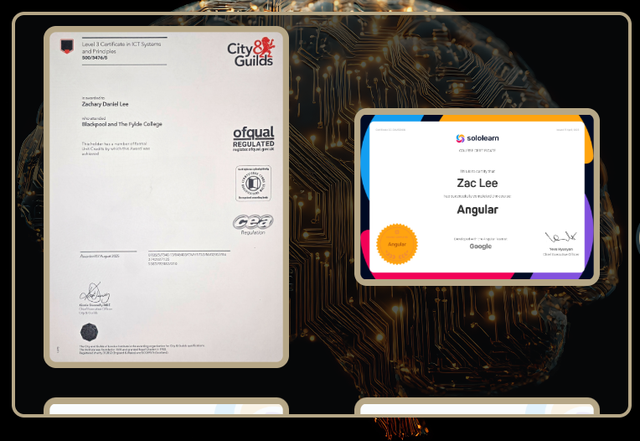

Side nav showing previous and next sections


Smooth Scrolling
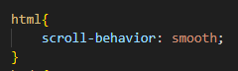

Showcase carousel buttons are above the images
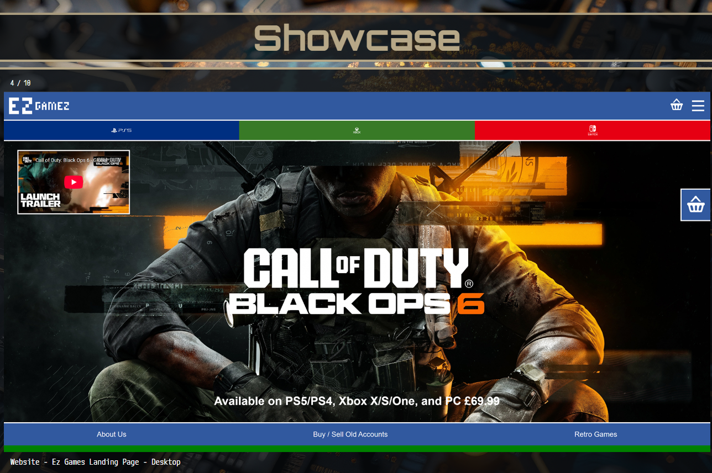

Show logo on Mobile Display


Showcase not showing correctly on mobile
G1.
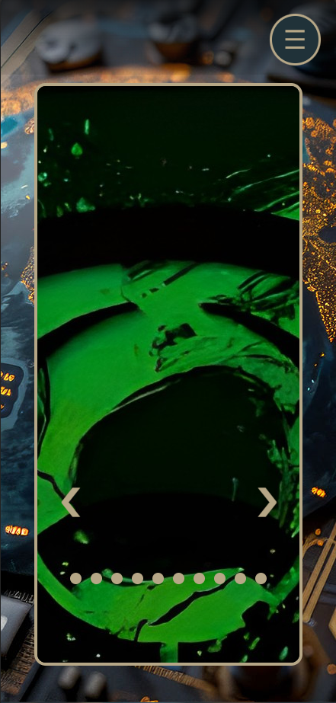
G2.
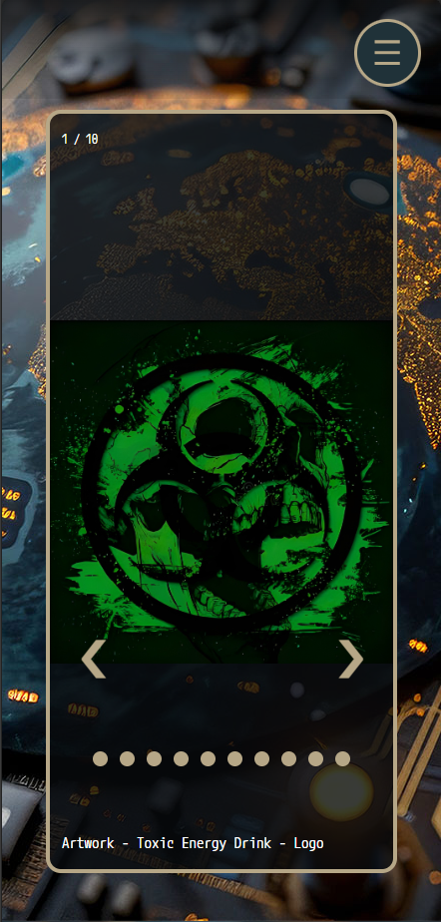

Background gradient on hamburger menu
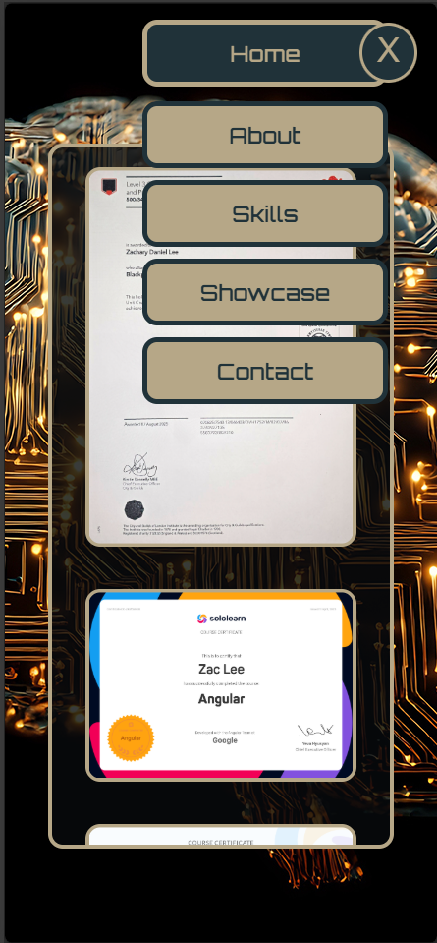

Mobile 4G site loading test
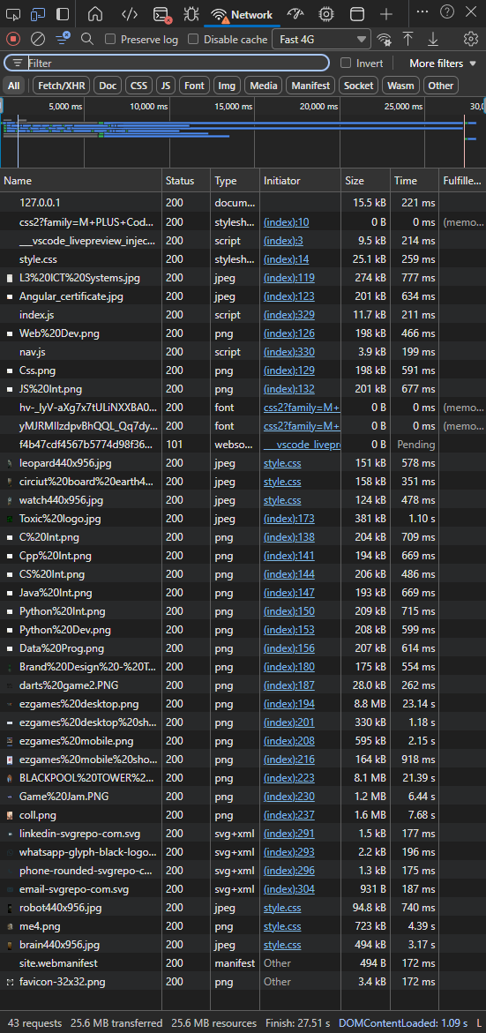

New windows for images
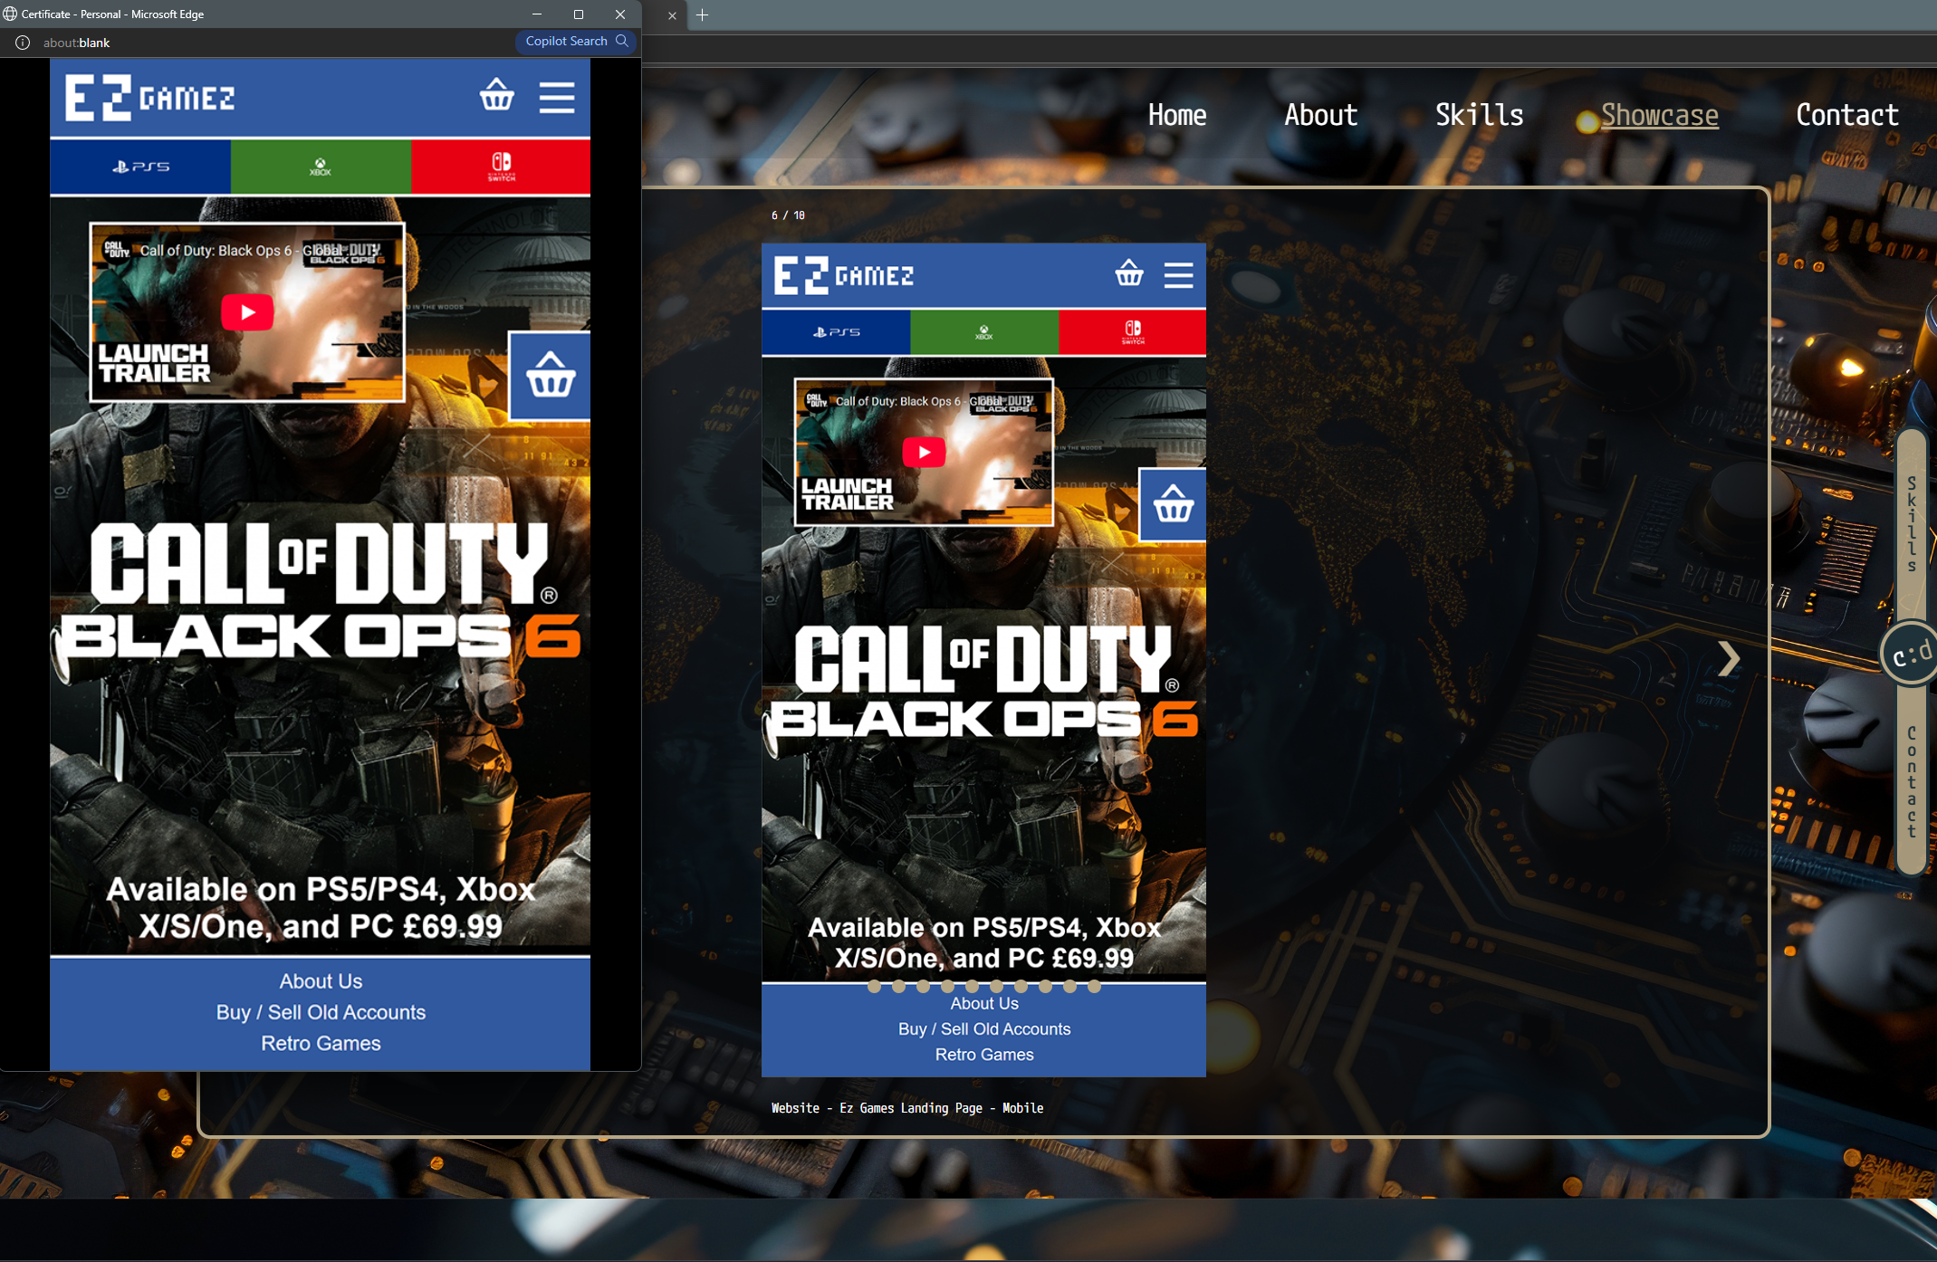

Windows opening in the centre of the screen

New windows disabled in tablet and mobile
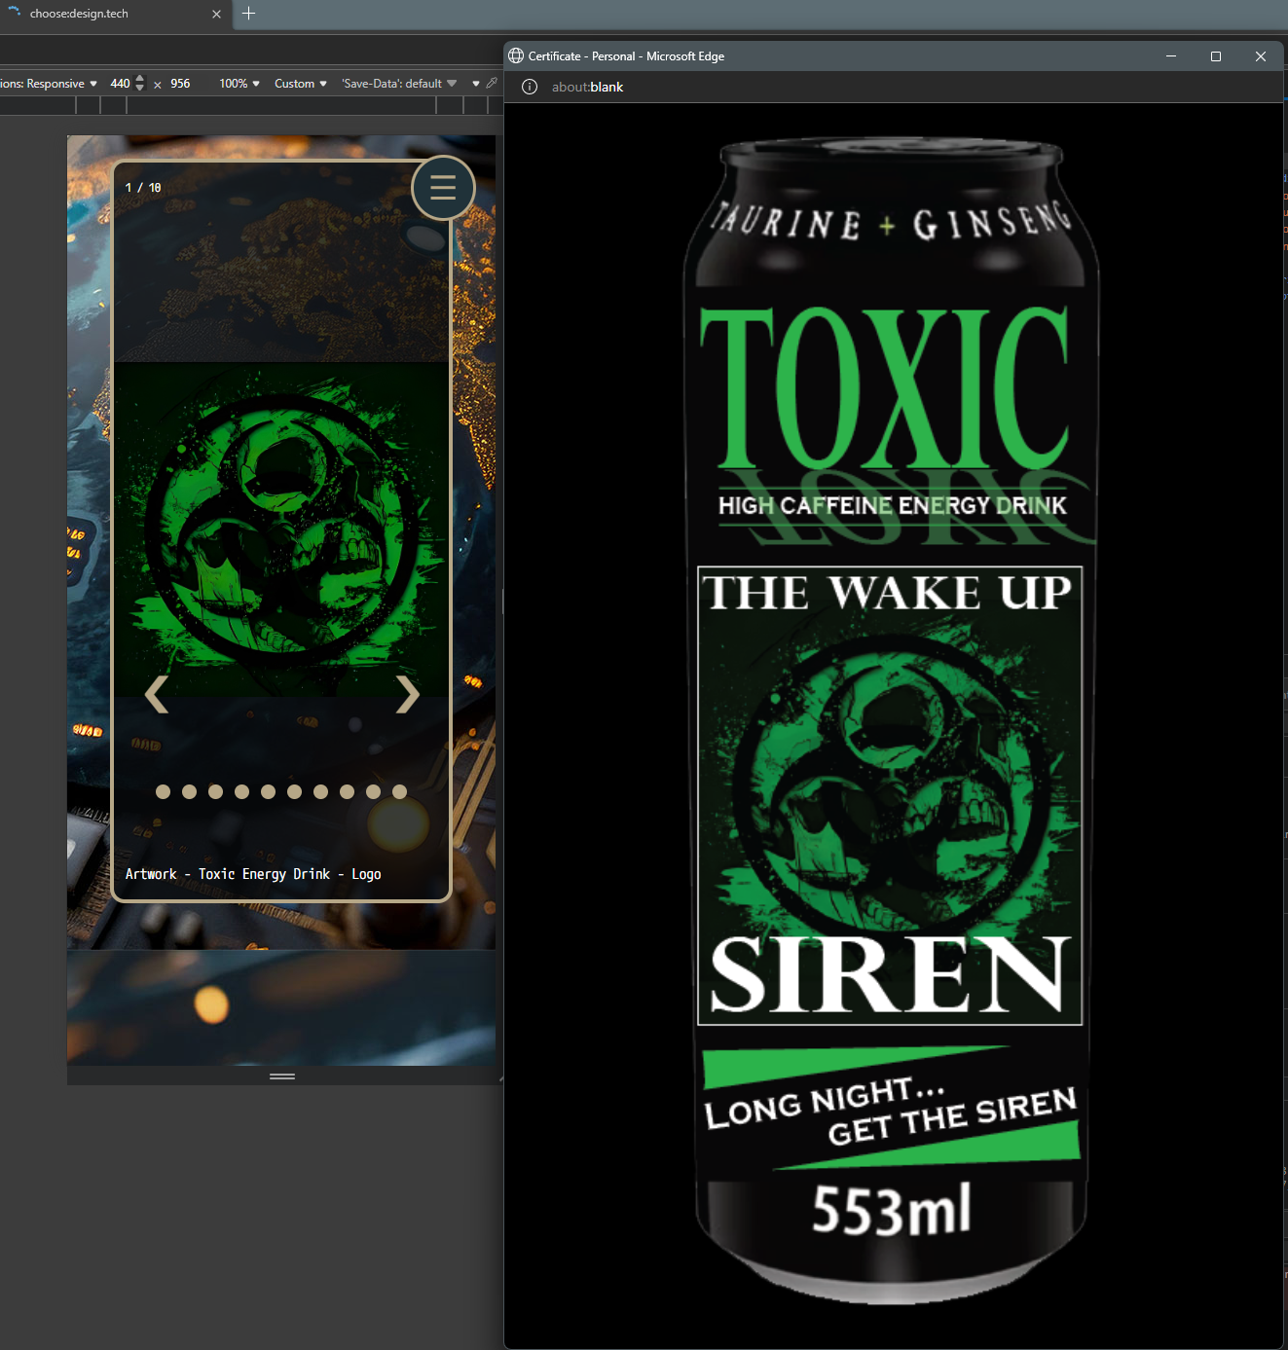

Images in Skills and Showcase still visible
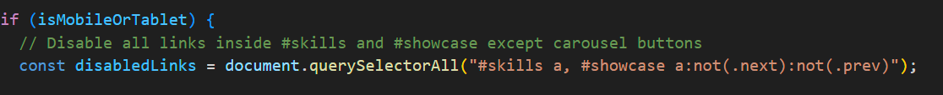

Images should be tablet 2 per row / mobile 1 per row

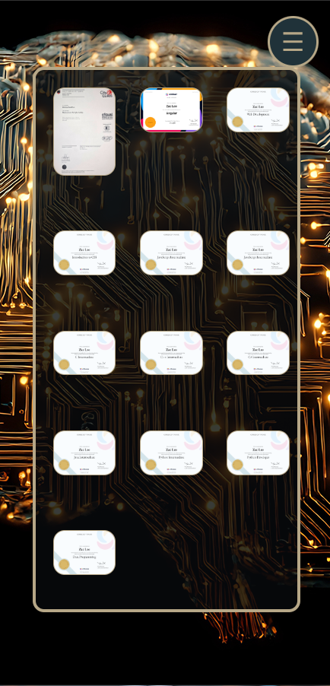

Mobile 4g with lazy load and prefetch
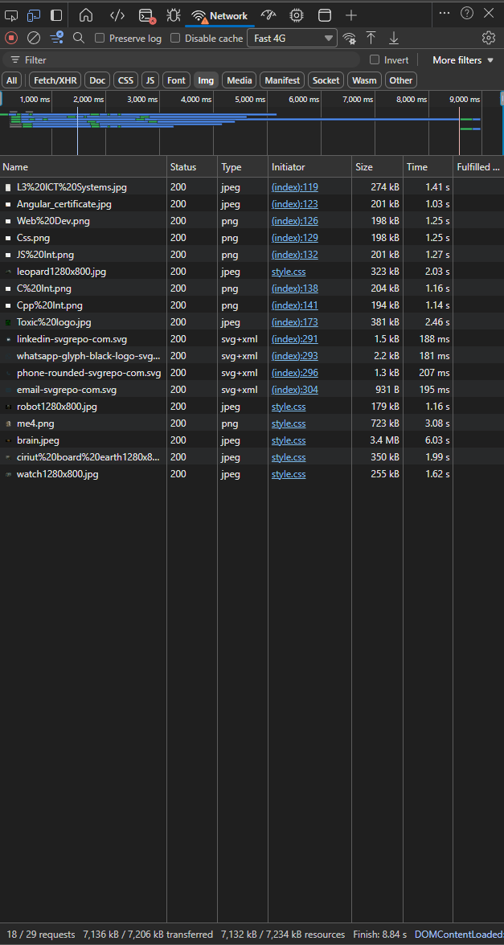

Submit Form
P1.
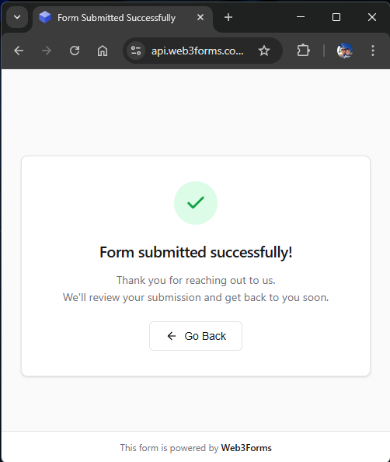

P2.
.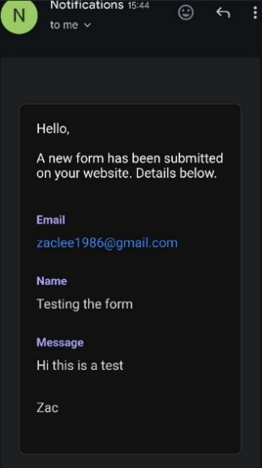

Side navigation updating dynamically


Smooth Scrolling Retest
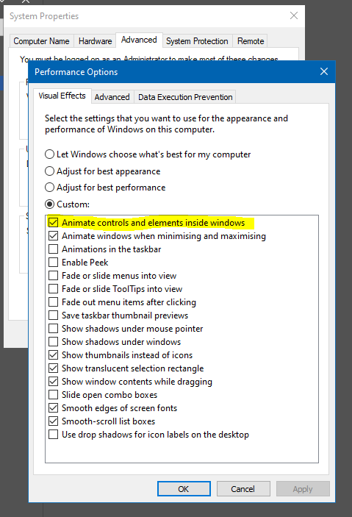

Carousel buttons above the images
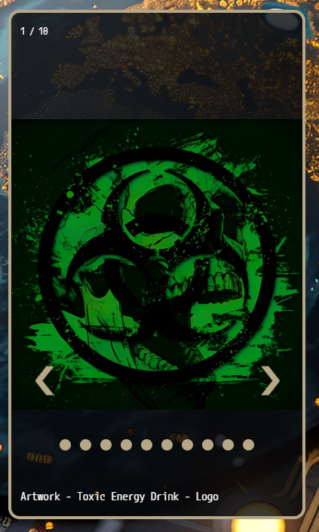

Logo displays correctly on mobile


Background gradient on nav showing on all sections
